Our Pinhole Camera

Screen

(Cardboard)

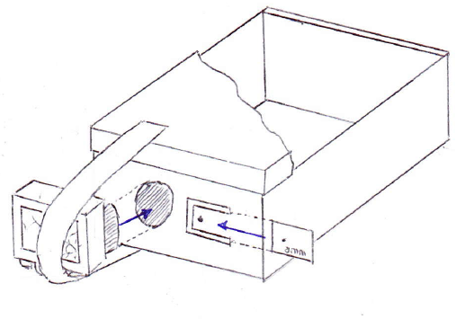

Not pictured: We wrap a jacket around the camera to further block outside light.

Shoebox

Pinhole Card

Slot for Pinhole Cards

Hole for DSLR

Camera Strap

Camera

(Upside Down)